CAPSTONE PROJECT APPROVAL FORM
DEPARTMENT OF COMPUTER ENGENEERING
Semester: 1st
1.0 Project Information
Project Name | Eqaab Drone
Project Area | Computer engineering

2.0 TEAM MEMBERS
Student ID | Name | Contact No | Email
44204081 | Abdulrahman Bandr Al-otaibi | 966505405811 | s44204081@students.tu.edu.sa
44201721 | Turki Faris Al-otaibi | 966566516802 | s44201721@students.tu.edu.sa
44201108 | Saeed Saad Al-harthi | 966506042659 | s44201108@students.tu.edu.sa
44252334 | Rayan Abdullah Al-ghamdi | 966533522211 | s44252334@students.tu.edu.sa
44152250 | Hossain abdulqadder Al-hubailee | 966535046917 | s44152250@students.tu.edu.sa
44254570 | Mohammed Faisal Al-sharif | 966533787316 | s44254570@students.tu.edu.sa
44207369 | Omar Abdullah Al-enazi | 966537451536 | s44207369@students.tu.edu.sa

3.0 SIGNATURES:
_____________________________ ________________________
Student (Team Leader) DATE
Abdulrahman Bandr Al-otaibi
Project Advisor DATE
Dr. Ahmed Bin Mahfoudh

Department Head or Project Coordinator DATE
Dr. Hanaa Mujaled

503413-3 Capstone Project
Department of Computer Engineering
Taif University

Project Title: Eqaab Drone

TO: Dr. Ahmed Bin Mahfoudh

FROM:
- Abdulrahman Bandr Al-dahhas
- Turki Faris Al-otaibi
- Rayan Abdullah Al-ghamdi
- Saeed Saad Al-harthi
- Hossain abdulqadder Al-hubailee
- Mohammed Faisal Al-sharif
- Omar Abdullah Al-enazi

Date of submission:

SUBJECT: Submission of Project Proposal for Approval
Enclosed is our group's project proposal. This proposal is submitted for partial fulfillment of the Capstone Project requirement. We understand this proposal, in written report as attached and oral presentation upon scheduled, would undergo a rigorous review process, and we are willing to accept recommendations and modify and resubmit for final approval.

TAIF UNIVERSITY
Fall 2025

CAPSTONE PROJECT PROPOSAL

Eqaap Drone

A Senior Project Submitted To:
Ahmed Bin Mahfoudh

The College of Computers and Information Technology in Candidacy for the Degree of
Bachelors in computer engineering

by

- Abdulrahman Bandr Al-dahhas
- Turki Faris Al-otaibi
- Rayan Abdullah Al-ghamdi
- Saeed Saad Al-harthi
- Hossain abdulqadder Al-hubailee
- Mohammed Faisal Al-sharif
- Omar Abdullah Al-enazi

Table of Contents
PROPSAL SUMMARY (ENGLISH) 7
ملخص مقترح البحث (عربي) 8
Introduction 9
Overview and Problem Background 10
Problem Statement: 11
Literature Review 13
Objectives 15
Proposed Methodology 16
Documentation 16
1. Document the design process, user manuals, and maintenance guides. 16
2. Prepare a final report summarizing the project, findings, and conclusions. 16
Presentation 16
1. Prepare a presentation to showcase the project to peers and faculty. 16
2. Highlight key features, user feedback, and future work. 16
System Design Model 18
Hardware components 19
Timetable or Schedule 20
Expected Benefits 25
References 27

PROPSAL SUMMARY (ENGLISH)

he goal of this project is to develop an advanced and intelligent air security system capable of accurately detecting, classifying, and locating vehicles through a drone-based surveillance platform. The proposed system leverages state-of-the-art artificial intelligence technologies, including computer vision and real-time image and video analysis, to autonomously detect and track targets during flight operations.
Beyond vehicle recognition, the system will also monitor and detect unauthorized human movements across border zones and identify unknown or hostile drones operating within restricted airspace in real time. By integrating these capabilities, the platform ensures a rapid response to potential threats without operational delay.
This project aims to enhance situational awareness and strengthen border and airspace security by delivering high detection accuracy, low latency, and stable performance under diverse environmental conditions. The system is intended to support military, governmental, and critical infrastructure protection applications, where reliable and intelligent surveillance is essential.

ملخص مقترح البحث (عربي)
يهدف هذا المشروع إلى تطوير نظام أمني جوي ذكي ومتطور، قادر على تحديد المركبات وتصنيفها وتحديد مواقعها بدقة، باستخدام منصة مراقبة تعتمد على الطائرات بدون طيار. يعتمد هذا النظام على أحدث تقنيات الذكاء الاصطناعي، بما في ذلك الرؤية الحاسوبية وتحليل الصور والفيديو في الوقت الفعلي، للكشف عن المركبات وتتبعها جوًا بشكل مستقل.
إلى جانب قدراته في التعرف على المركبات، سيُصمَّم النظام لرصد وكشف أي تسلل بشري غير مصرح به عبر الحدود، كما سيتمكن من تحديد وتتبع الطائرات بدون طيار مجهولة الهوية أو غير المصرح لها التي تعمل في المجال الجوي المحظور في الوقت الفعلي، مما يضمن استجابة سريعة ودقيقة دون تأخير.
يهدف هذا الحل إلى تعزيز الوعي الظرفي وأمن الحدود من خلال توفير دقة عالية، وزمن استجابة منخفض، وأداء موثوق في مختلف الظروف البيئية، مما يجعله مناسبًا للتطبيقات العسكرية والحكومية ولحماية البنية التحتية الحيوية..

Keywords: Unmanned Aerial Vehicle (UAV), Drone Surveillance, Air Security System, Object and Threat Detection, Vehicle Tracking, Image and Video Analysis, Color Recognition, Artificial Intelligence (AI)

Introduction

Nowadays, drones are becoming very useful in the field of security and surveillance. Traditional monitoring systems such as fixed cameras or ground sensors cannot cover wide areas or react quickly to moving targets. Because of this limitation, our project aims to design a security drone that can detect vehicles, identify their type and color, and recognize humans or unknown drones that enter restricted or border zones.

In this project, the drone will be controlled by a person using a remote control, not flying completely by itself. However, it will use artificial intelligence (AI) and computer vision to automatically analyze the video feed and detect objects in real time. The smart system will help the operator by identifying what appears in front of the camera, such as a car, a person, or another drone, and providing clear information about each target.

This combination of human control and AI assistance makes the system more reliable and easier to use. The operator can focus on decision-making while the drone handles detection and classification automatically.

The project is designed to support internal security and border protection by providing a faster and smarter way to monitor sensitive areas. It can help security forces detect intruders or unauthorized drones early, which improves response time and reduces risks. This drone system could be a valuable tool for national safety and help protect important facilities and border zones effectively.

Overview and Problem Background

Border areas and high-security zones face constant challenges in keeping track of unauthorized movements and possible threats. Fixed cameras often leave blind spots, making it easier for intruders to slip through. Relying only on human operators can cause delays or mistakes, especially when they get tired or distracted. Rugged and remote terrains make it hard to cover everything, which lowers the effectiveness of traditional systems. Security incidents are sometimes recorded incompletely, making reviewing and analyzing events more complicated.
Because of these problems, a more flexible and automated solution is needed. A drone that can track objects offers a smart way to patrol large areas, spot moving targets in real time, and react quickly. By combining AI, computer vision, and GPS, the system can provide continuous and reliable monitoring — improving safety and situational awareness.

Problem Statement:
‏I. Problem Statement Limitations of Traditional Surveillance Systems
‏Conventional fixed surveillance infrastructure faces several critical limitations that reduce its reliability and effectiveness in sensitive or large-scale security environments:
‏1. Limited Coverage and Terrain Constraints
‏Fixed security systems are unable to provide full coverage in wide, rugged, or remote areas. This creates surveillance blind spots that can be exploited for unauthorized entry or illegal activity.
‏2. Dependence on Human Monitoring
‏Manual surveillance requires constant attention from operators, leading to fatigue and decreased focus over time. This significantly increases the likelihood of human error and reduces overall detection accuracy.
‏3. Delayed Emergency Response
‏Traditional systems often rely on human verification before initiating any action, which results in slower response times and delays in containing or neutralizing security threats.
4. Insufficient Event Documentation
‏Most conventional monitoring methods lack advanced tracking and data integration capabilities. This results in incomplete records of incidents, making post-event investigations more complex and less accurate.

‏II. Proposed Solution Smart Object-Tracking Drone System
To address these issues, the proposed system integrates autonomous drone technology with real-time computer vision and AI tracking to enhance security operations in critical areas:
‏1. Flexible and Wide-Area Coverage
‏Unlike fixed systems, the drone can patrol large and complex terrains quickly and efficiently, significantly reducing blind spots and increasing surveillance reach.
‏2. Real-Time Object Detection and Tracking
‏The drone leverages advanced AI models to detect and track moving objects automatically. This ensures accurate and continuous monitoring of potential threats with minimal human intervention.
‏3. Low Latency Through Onboard Processing
‏By processing detection and tracking data directly on the drone’s edge-computing unit, the system minimizes transmission delays, enabling instant alerts to the control center.
‏4. Accurate and Reliable Event Logging
‏The drone records high-resolution video synchronized with precise GPS coordinates, creating a complete movement log of detected objects. This supports fast decision-making and post-incident analysis.
‏5. Operational Reliability in All Conditions
The integration of thermal and visible-spectrum cameras ensures the system remains fully functional during both day and night, and under various weather conditions.

Literature Review

Drones today are becoming one of the most useful tools in the field of security and monitoring. They can move quickly, cover large areas, and give live video to the operator in real time. In our project, the drone is designed to help in security missions, such as detecting vehicles, people, and unknown drones. It will be controlled by a person using a remote control, not flying fully by itself. However, it will use artificial intelligence (AI) to recognize what appears in front of the camera and to make the detection process faster and more accurate.
The drone includes several main parts. The frame is made of light polymer material, which makes it strong and easy to carry without adding much weight. The Pixhawk flight controller is used to control the motors and keep the drone stable during flight. The GPS helps the drone know its location, while the IMU sensor tracks movement and direction. A Raspberry Pi works as a small onboard computer that processes the video and runs the AI model used for object detection. The Li-Po battery provides the needed power for long flight time, and the wireless communication module keeps a stable connection with the operator to send live images and receive commands.
The main task of the drone is to detect and identify different objects. It can detect a vehicle and tell its type and color, or detect a person moving in a restricted area. It can also recognize unknown drones flying nearby, which helps protect the airspace from intruders. These features make the system useful for border protection, military areas, and national security, where quick detection can prevent serious problems.

Artificial intelligence is the key part that makes this system smart. It uses computer vision algorithms like YOLO or other models that can find and classify objects in real time. The AI doesn’t fly the drone, but it helps the human operator by analyzing the video automatically. This means the person controlling the drone doesn’t have to manually look for every object — the system will highlight what it sees, such as a car or a person, and show it on the screen.
However, there are still some challenges that need to be considered. Adding too many sensors can make the drone heavy and reduce battery life. Also, weather conditions such as strong wind, dust, or very high temperature can affect camera accuracy and flight control. To solve this, the drone must be designed carefully with a balance between performance and weight. Using good materials, stable sensors, and efficient power systems can improve reliability and make the drone suitable for different environments.
Another challenge is communication range. In border or remote areas, the connection between the drone and the operator must stay strong. Using long-range Wi-Fi or radio systems helps keep control even when the drone flies far away. Good communication also allows live video to reach the ground station without delay, which is important in security operations.
In general, drones that mix human control and AI-based detection offer a great advantage in modern security systems. The human operator remains responsible for flying and decision-making, while the AI helps in detecting, identifying, and tracking objects faster and more accurately. This teamwork between human and technology makes the system safer, smarter, and more effective for internal security and border protection.

Objectives
In this project, we aim to achieve the following objectives:
- Develop an intelligent surveillance system using an unmanned aerial vehicle (UAV) capable of autonomously tracking moving objects in real time without direct human control.
- Enhance border and security monitoring by detecting unauthorized movements and sending instant alerts to authorities.
- Enable the drone to identify different types of targets such as vehicles, people, or other drones through computer vision and AI-based object detection.
- Distinguish friendly drones from unknown or hostile ones using a digital ID broadcasting system to reduce false alarms and improve detection accuracy.
- Transmit the GPS location of suspicious targets to the control center for rapid response and tracking.
- Experiment and test autonomous tracking technologies to build a prototype that can be further developed for security, defense, and civilian applications.

The goal of this project is to design and develop a smart drone capable of autonomously detecting and tracking moving objects—such as vehicles or other drones—in border and security zones. The system aims to enhance real-time surveillance, improve situational awareness, and support security forces with automated alerts and precise location tracking.

Proposed Methodology

Documentation

Document the design process, user manuals, and maintenance guides.

Prepare a final report summarizing the project, findings, and conclusions.

Presentation

Prepare a presentation to showcase the project to peers and faculty.

Highlight key features, user feedback, and future work.

Testing and Evaluation
- Functional Testing: Verify that all features work as intended.
- User Testing: Conduct tests with real users to gather feedback on usability and performance.
- Iterative Improvements: Refine the design based on user feedback and testing results.

Scope of Work

This section explains what the project will cover and the main work that will be done to build the security drone system. It describes the parts of the project, including the hardware, software, and testing, and shows what the team will focus on during the development process.

System Design Model

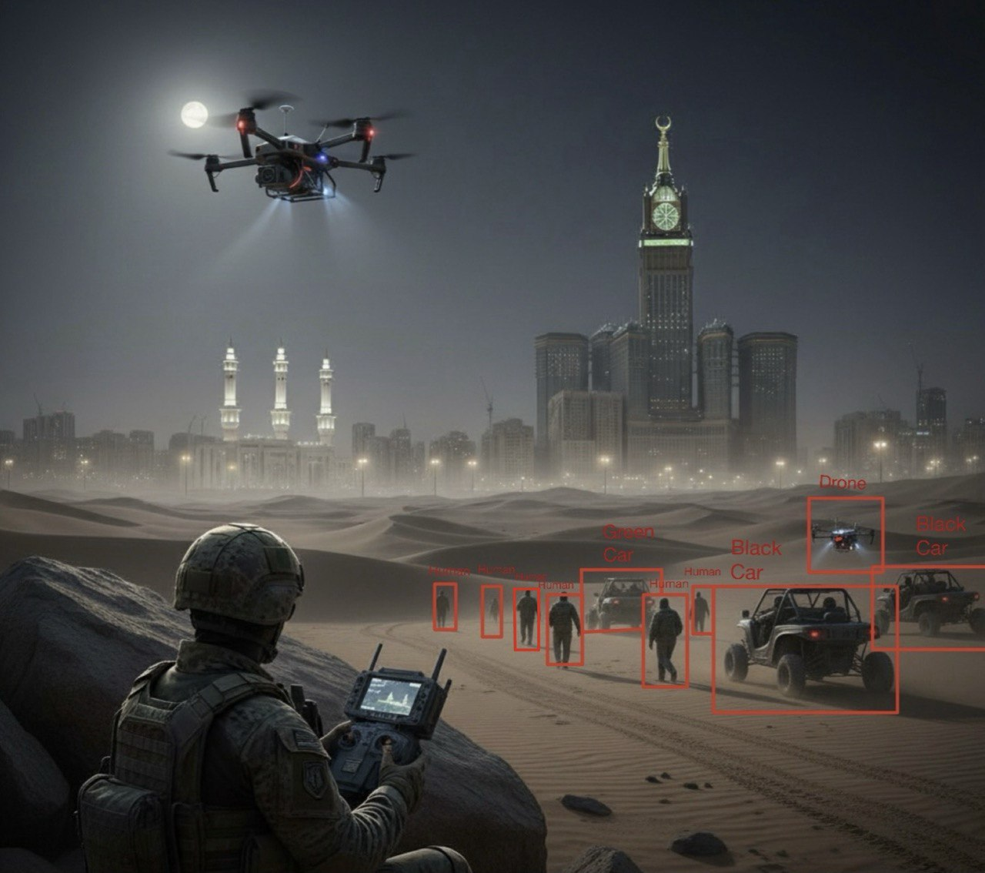

Figure 1 System Model Diagram

Hardware components

1 | Drone Frame | 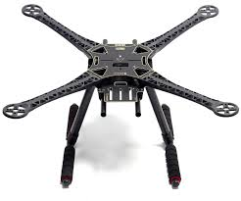 | 6 | Remote Controller | 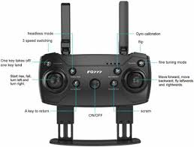
2 | Drone Motors | 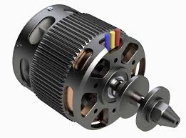 | 7 | Camera | 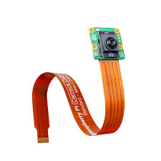
3 | Pixhawk Flight Controller | 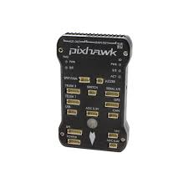 | 8 | Wiers | 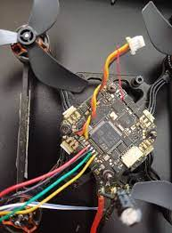
4 | GPS Module | 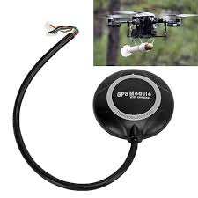 | 9 | Lithium Battery | 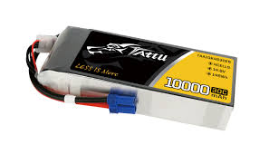
5 | Raspberry Pi 5 | 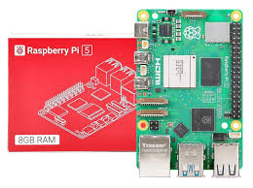 | 10 | Long range Wifi | 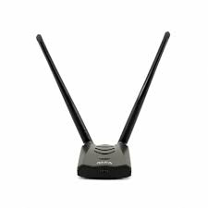

Some components may be subject to change

Timetable or Schedule

  - Semester 1 Schedule
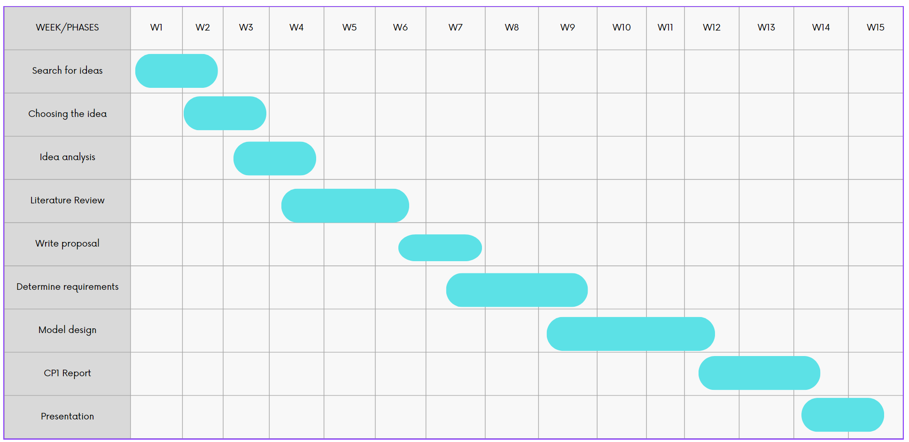
Figure 2 Activity Plan Part I

  - Semester 2 Schedule
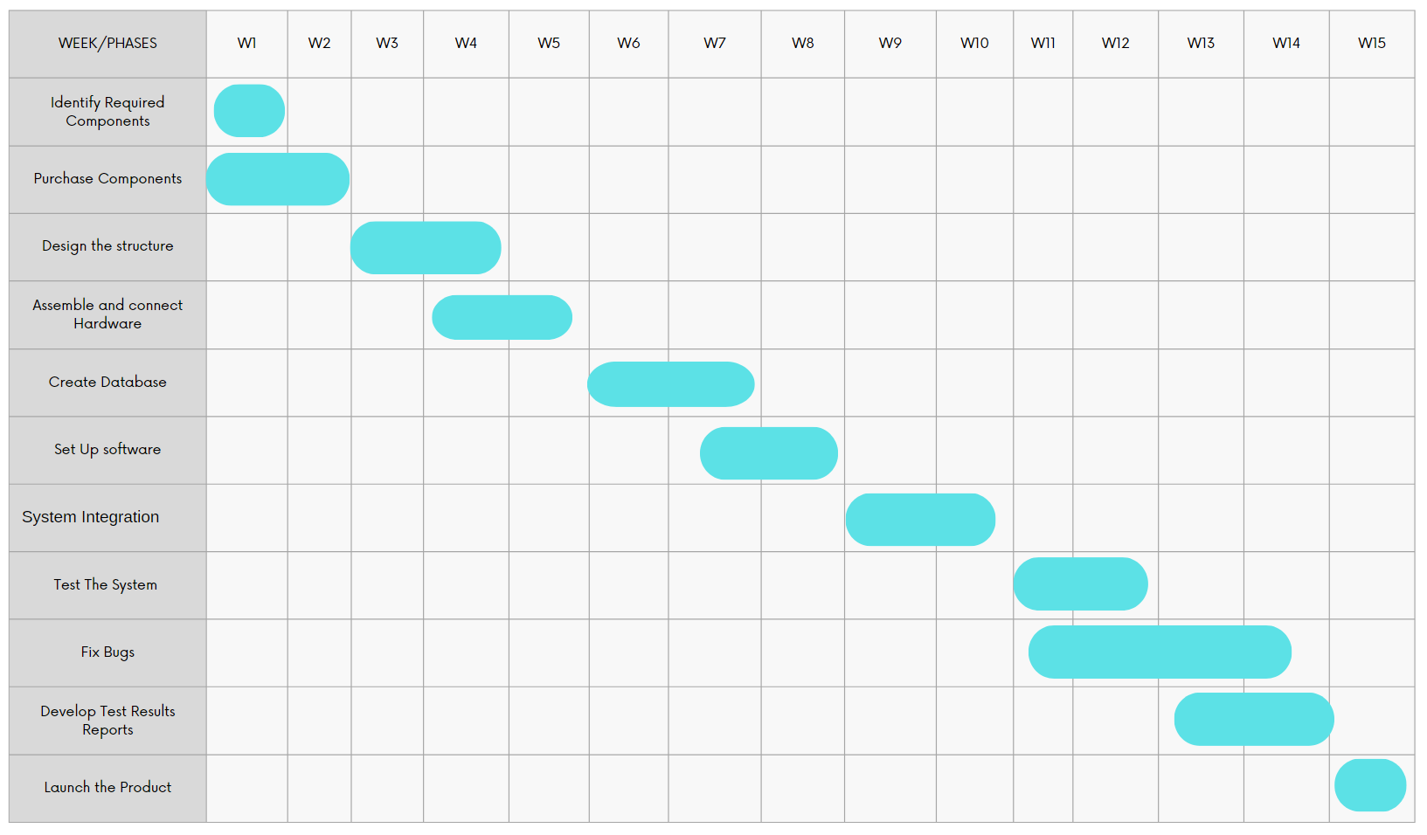
Figure 3 Activity Plan Part II

Software Tools and Technologies

The software is going to be the brain of the Eqaab drone, so we are aiming to design it to be reliable, fast, and intelligent. To achieve this, we’ve structured our software plan into three main pillars: a system for flight control, an AI agent that drives its intelligence, and the development tools that bring everything together

1. Flight Control: This component handles the drone’s autonomous navigation and hardware communication, using MAVLink for standard data exchange. The following tools will be used:
- Onboard Computer: A Raspberry pi 5 running Ubuntu OS will serve as the central processing unit for all high-level tasks.
- Flight Control Firmware: The PX4 open-source firmware will be used for its reliability and robust performance in drone applications.
- Middleware: The Robot Operating System (ROS) will function as the middleware to facilitate seamless communication between the perception and control subsystems.
- Simulation & Validation: All flight algorithms will be rigorously tested and validated for precision and safety in Gazebo and MATLAB/Simulink environments prior to physical deployment.
2. Artificial Intelligence and Computer Vision: The drone’s AI-powered computer vision pipeline enables real-time object detection and tracking, using:
- Image Processing Library: OpenCV will be used for fundamental, real-time image processing tasks.
- Object Detection Model: The YOLOv8 algorithm will be implemented for high-accuracy, real-time object detection and tracking.
- Deep Learning Framework: TensorFlow has been selected for training and fine-tuning the detection model, chosen for its flexibility and rapid prototyping capabilities. This combination ensures the system can accurately monitor dynamic targets in complex environments.
3. Development Environment and Collaboration Tools: A structured development environment and a clear version control strategy are essential for the project's success. The environment will consist of:
- Programming Languages: Python will be the primary language for implementing AI logic and high-level scripts, while C++ will be used for performance-critical, low-level control tasks.
- Integrated Development Environment (IDE): Visual Studio Code will be the main code editor for development. Google Colab will be utilized for cloud-based training and testing of machine learning models.
- Version Control: Git and GitHub will be used for source code management and team collaboration, ensuring a traceable and organized development workflow.

Expected Benefits

1. Fully Autonomous Flight Operation:
The drone will be capable of a complete autonomous mission cycle: automatic takeoff, precise hovering, robust navigation, and autonomous safe landing This capability is built upon the robust and reliable PX4 flight stack, which handles the low-level flight stabilization and control.

2. Accurate Real-Time Object Detection: The system will consistently identify and classify specific target objects (e.g., vehicles, people, other drones) within its camera feed using the YOLOv8 model, even in cluttered or dynamic environments.
3. Persistent and Responsive Object Tracking: The primary outcome is the drone's ability to autonomously lock onto a designated target and maintain its tracking. This means: · The drone will automatically adjust its flight path (position, velocity, orientation) to keep the target within the camera's frame. It will be able to follow a moving target, compensating for the target's changes in speed and direction.
Performance and Reliability Outcomes
- Low-Latency Response: The integration of a fast model (YOLOv8) with efficient communication (ROS) and a real-time flight controller (PX4) will result in a very short delay between the target's movement and the drone's corrective action. This is critical for tracking fast-moving objects.
- High System Reliability and Safety: The use of Gazebo and MATLAB/Simulink for simulation means the drone's flight algorithms will be thoroughly tested and validated in a virtual environment. This leads to a safer, more predictable, and crash-resistant system in the real world.
- Robust Performance in Dynamic Environments: The combination of OpenCV and a fine-tuned YOLOv8 model will allow the drone to maintain tracking despite challenges like changing lighting conditions, partial occlusions, and complex backgrounds.

Constraints and Limitations
The project has some limitations related to hardware, time, and testing environment. The Raspberry Pi may have limited processing power to run AI models in real time, and the battery life might restrict flight duration. Also, the available dataset for unknown drones and intruders is limited, which could affect detection accuracy.
Time and budget constraints may also limit the number of tests and high-end hardware components. Finally, testing outdoors may be restricted due to weather.

References
- Object Detection from Drone Surveillance, GitHub Repository
https://github.com/nia194/Object-Detection
- Efficient Object Detection Model for Real-Time UAV Applications, arXiv Preprint
https://arxiv.org/pdf/1906.00786
- Drone-Mounted Object Detection and Recognition Using Machine Learning and Infrared Sensors, UCF Short Report
https://creol.ucf.edu/wp-content/uploads/sites/2/2024/08/2023_Spring_G3_Short_Report.pdf
- Deep Drone Object Detection Using Convolutional Neural Networks, Stanford University Project Report
https://web.stanford.edu/class/cs231a/prev_projects_2016/deep-drone-object__2_.pdf
- ROS (Robot Operating System) Documentation
https://docs.ros.org
- Real-Time Object Detection and Tracking for Unmanned Aerial Vehicles Based on Convolutional Neural Networks
https://www.mdpi.com/2079-9292/12/24/4928

